Diode Circuits HW 2 (28 points + 6 Extra Credit)
(jas, Diode Circuits HW 2.docx, 10/07/2025)
Clearly indicate answers and include units for numeric answers, using 3 or 4 significant figures. Show at least the major steps of your work so that if necessary partial credit can be awarded.
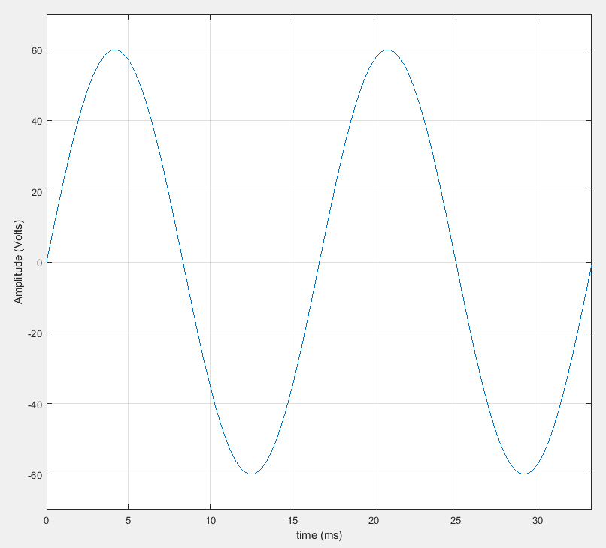
- An ideal full-wave diode bridge rectifier is used to rectify the adjacent sine wave with 60 V peak voltage. (6 points total.)

- Determine the average voltage of the adjacent sine wave prior to rectification.
(2 points.)

Before Rectification V_{avg} = 0V

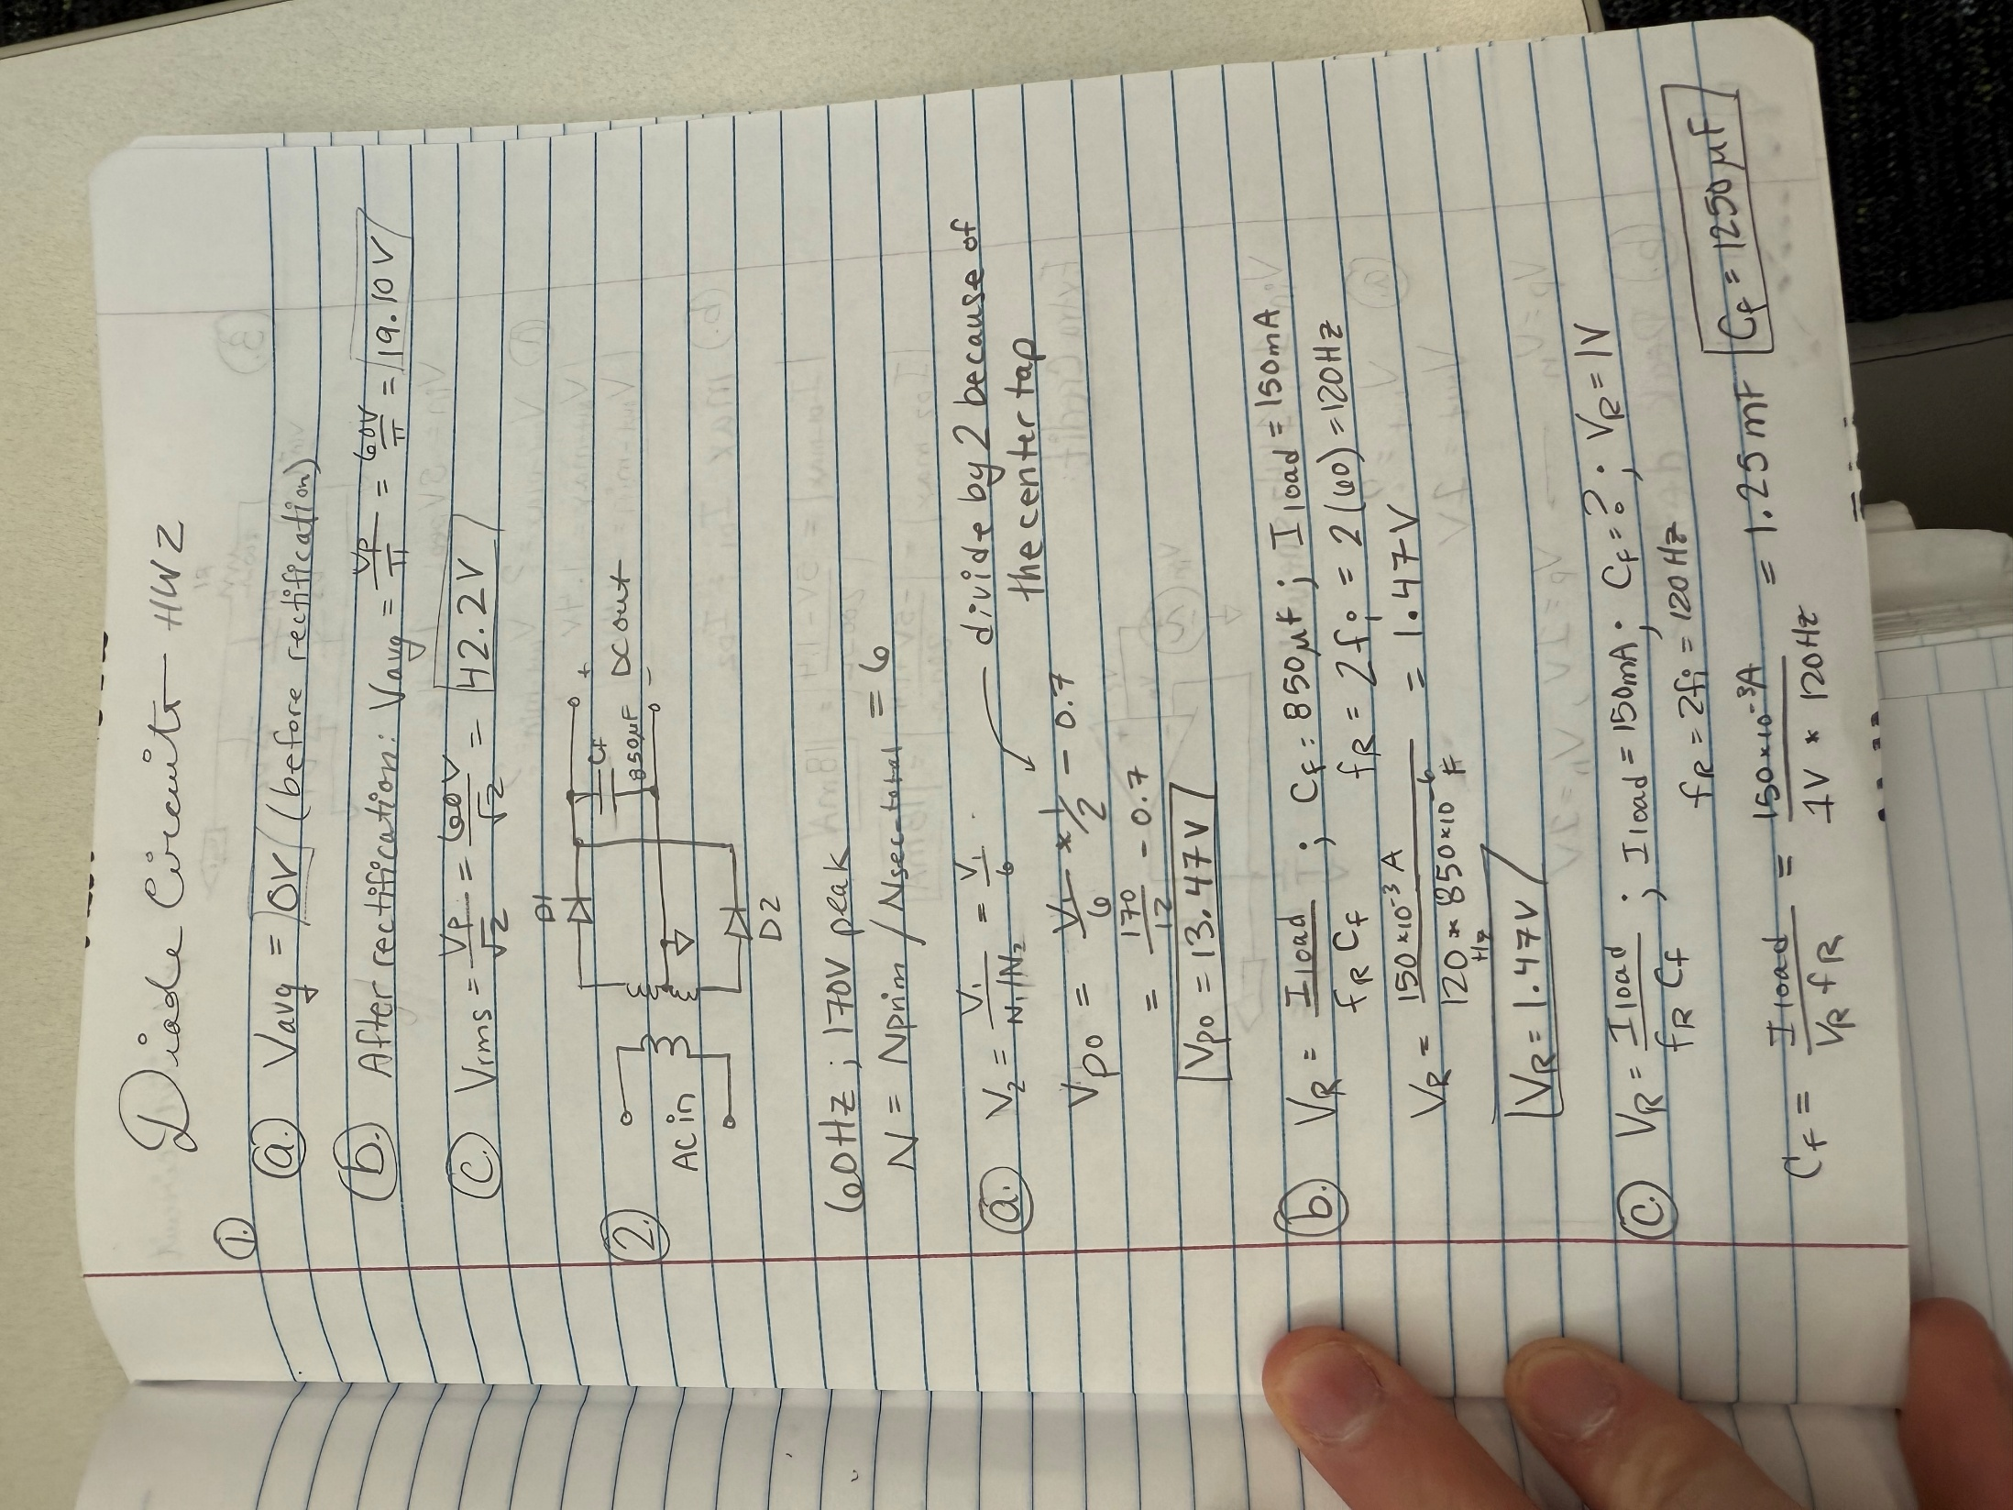

- Determine the average voltage of the above sine wave after ideal full wave rectification. (2 points.)

After Rectification V_{avg} = 19.10 V


- Determine the rms voltage of the above sine wave after ideal full wave rectification. (2 points.)

After Rectification V_{rms} = 42.2 V

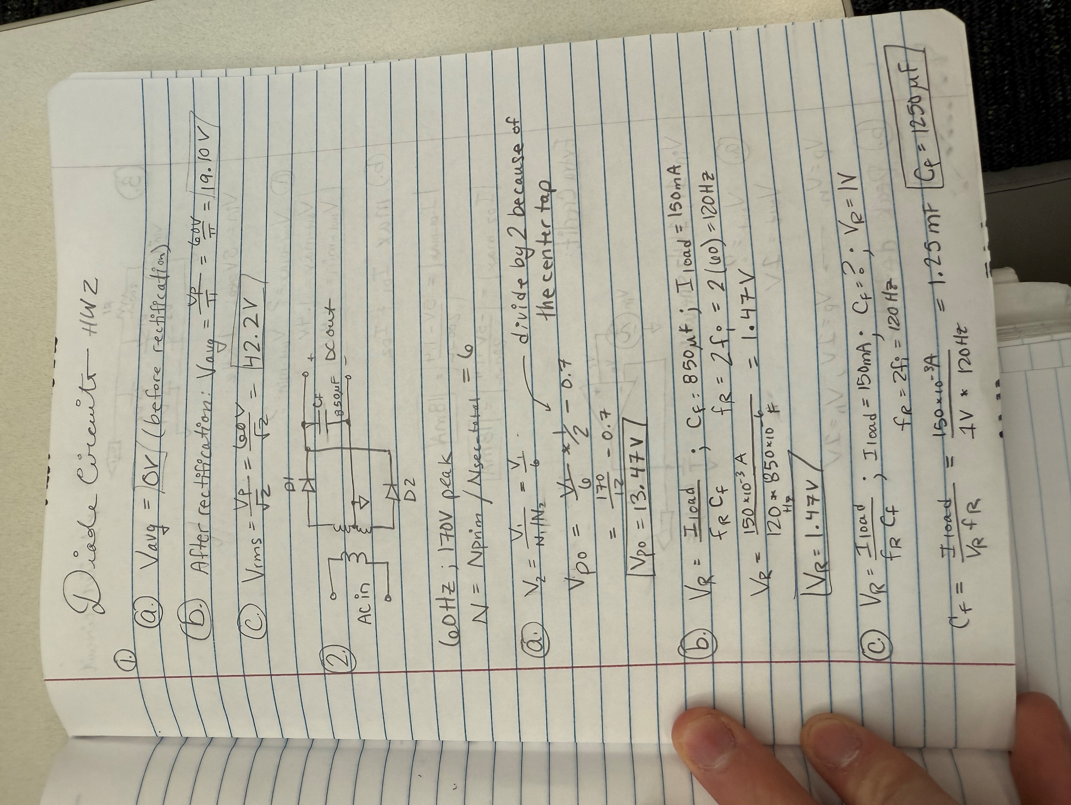
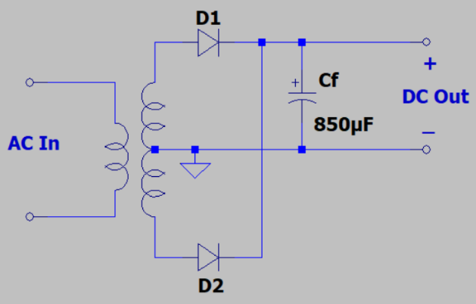
- Determine the following parameters for the adjacent full-wave rectifier circuit with a 60 Hz 170 V peak sine wave input that utilizes a center tapped transformer with an overall turns ratio N = N_{prim}/N_{sec_Total} = 6. (Hint: The peak output voltage should be between 13 and 14 V.) (6 points total.)

- The peak output voltage using the simplified diode model, i.e., 2nd approximation, with V_{k} = 0.7 V for diodes D1 and D2. (2 points.)

V_{peak_out} = 13.47 V

- The output ripple voltage for an average load current of 150 mA, using the following equation for full-wave rectifiers described in the class slides: (2 points.)
$V_{R}=\frac{I_{load}}{{f_{R}C}_{f}}.$
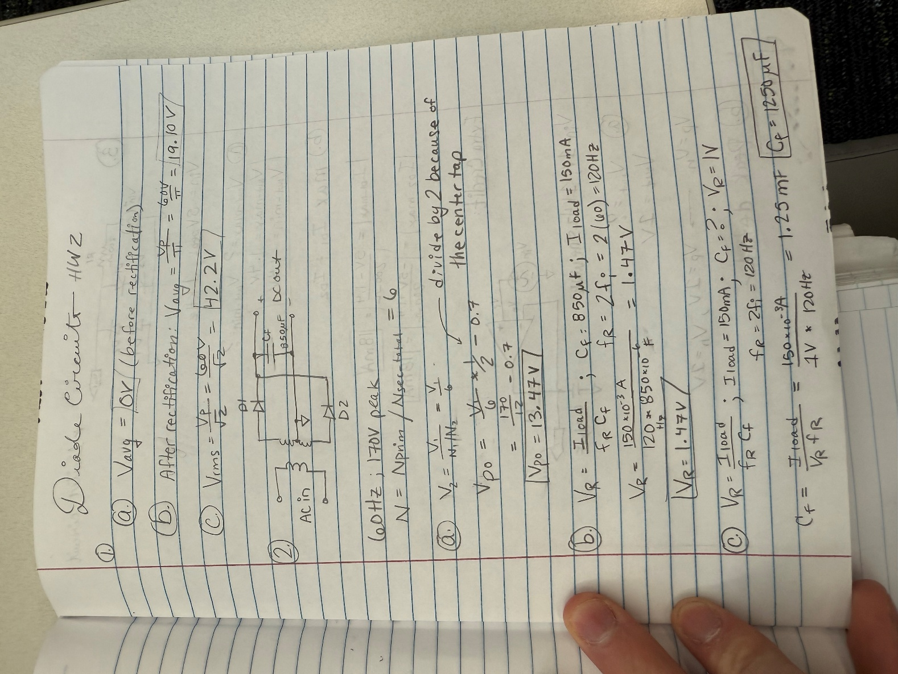
V_{R} = 1.47 V
- The required filter capacitor required for a 1 V output ripple voltage for an average load current of 150 mA. (2 points.)

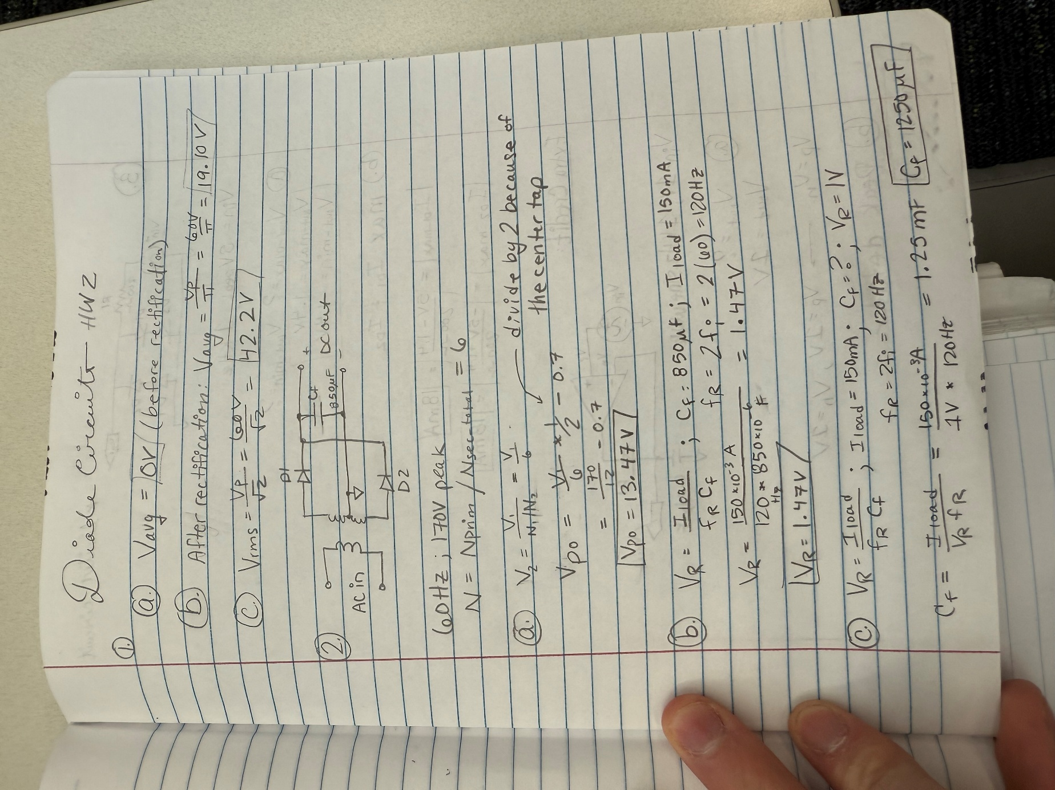

C_{f} = 1250 µF

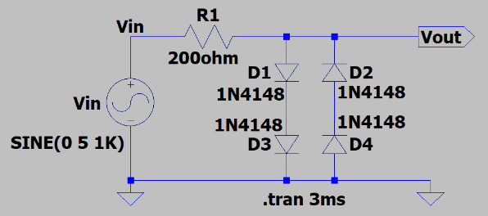
- For the adjacent diode limiter circuit, the input voltage V_{in} is a 5 V peak, 1 kHz sine wave, with all diodes being 1N4148 silicon pn junction switching diodes.
(8 points total.)

- Determine the most positive (V_{out_max}) and the most negative (V_{out_min}) output voltages, using the Simplified Diode Model, i.e., 2nd Approximation, with V_{K} = 0.7 V for a forward biased diode. (4 Points, 2 points each.)

V_{out_max} = 1.4 V

V_{out_min} = -1.4 V

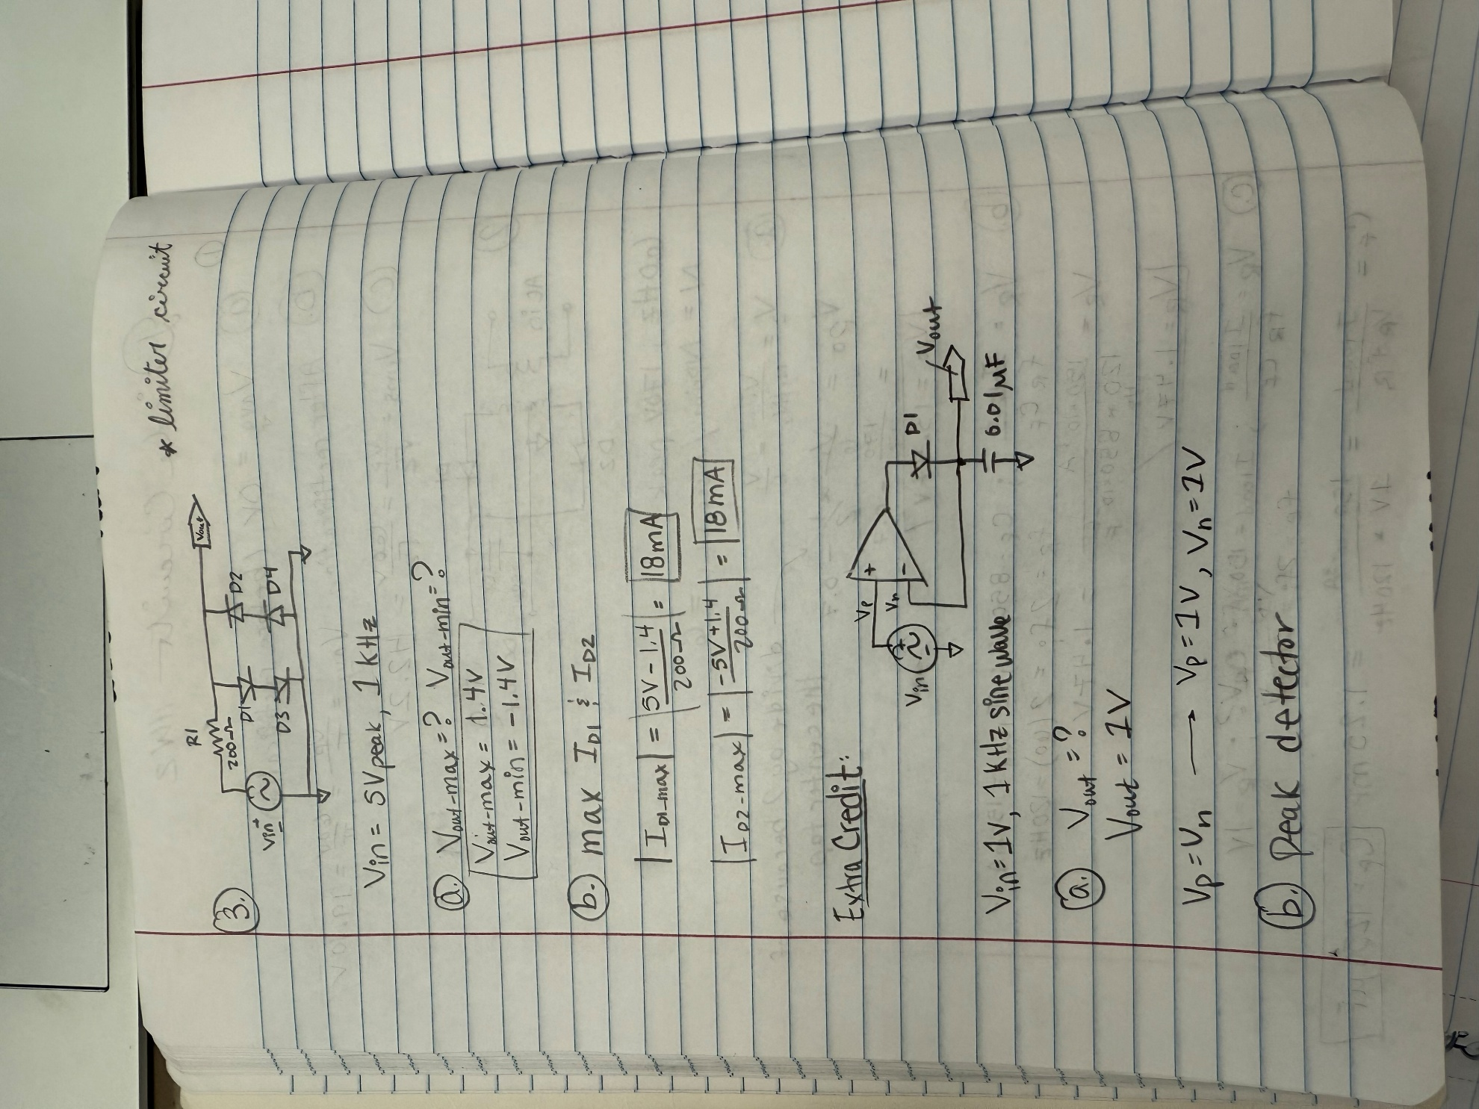

- Determine the maximum magnitude of diode currents I_{D1} and I_{D2}. (4 Points, 2 points each.)

|I_{D1_max}| = 18 mA

|I_{D2_max}|= 18 mA



- Construct the diode limiter circuit in the previous problem in LTspice with a 5 V peak, 1 kHz sine wave for V_{in}, along with the 1N4148 switching diodes for D1 – D4. To place 1N4148 switching diodes, 1st place the default diode in LTspice. The sine wave voltage source symbol shown in the figure can be found in the [Misc], library as a signal component, although the standard voltage source also works in the simulation. A model for the 1N4148 switching diode is in the standard LTspice parts library. Consequently, you can place a generic diode on your schematic followed by changing the diode Value from D to 1N4148. Add a net name of Vin to the schematic so that the input voltage can be easily plotted. Choose Transient Analysis with a 3 ms duration.

After running the simulation, and the plot pane opens, select Plot Settings Add Plot Pane to have two separate plot panes. For the top plot pane select the voltage traces V(vin) and V(vout). For the bottom plot pane select the traces I(D1) and I(D2). Next attach both cursors to the V(vout) trace and adjust one cursor to the maximum voltage and the other cursor to the minimum voltage. Both the mouse and the left and right arrow keys can be used to move the waveform cursors along a given trace. Then drag the cursor pane onto your plot to document your maximum and minimum V(vout) values as illustrated in the figure below. In the Edit pull-down menu, add your name to your plot pane as follows: Plot Settings Notes & Annotations Place Text. Replace the plot pane shown below with your version, including your name, along with the cursor pane indicating diode currents.
(8 points.)
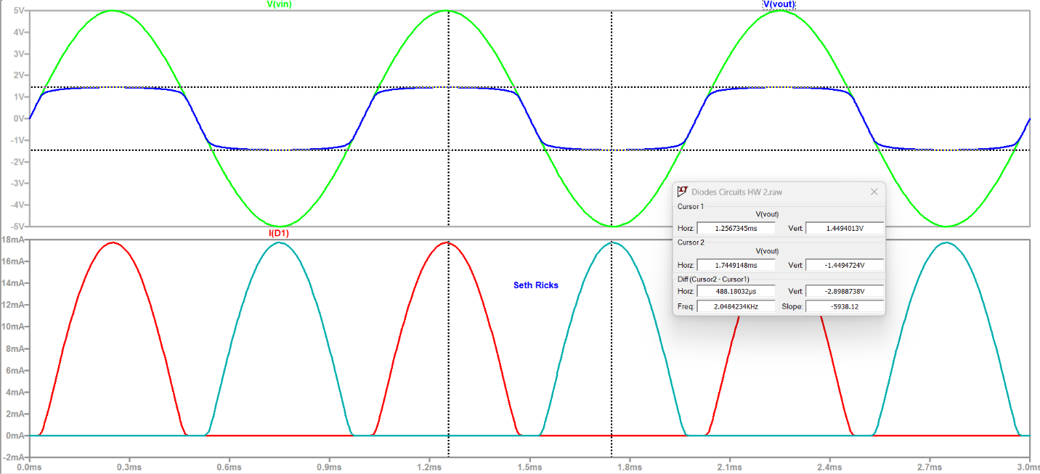

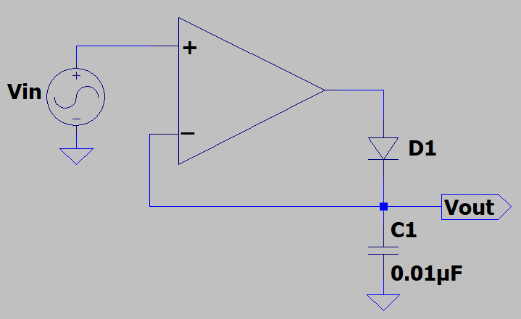
Extra Credit Problem: In the adjacent circuit, diode D1 is a standard silicon pn junction diode with a knee voltage V_{K} = 0.7 V. A steady-state 1 V peak, 1 kHz sine wave is connected to the plus input of the op-amp. The capacitor C1 maintains the voltage V_{out} when diode D1 is reversed biased. (Note: Negative feedback exists in the adjacent op-amp circuit whenever V_{in} is greater than V_{out}.)
(6 points total.)

- Assuming an ideal op-amp, determine the output voltage V_{out}, in the adjacent circuit. Explain your reasoning for the value of V_{out}, as a correct answer without any explanation will only receive 1 out of 4 points. (4 Points.)

V_{out} = 1 V

Per the rules of operational amplifiers, the negative input must match the positive input. This means that if the positive input is 1 V, the op amp tries to change the output to create a 1 V input in the negative side. In this case, the output of the op amp would be 1.7 V, the voltage across the diode would be 0.7 V, and Vout would be 1V. This is when the peak value of the voltage is reached. Afterwards, when the sine wave voltage from the generator starts to decrease, the op amp tries to decrease the value going into the negative input. But since the capacitor still holds the largest voltage value, the op amp is unable to match the inputs. When the voltage changes polarity, the diode is reversed biased and no current flows.

- Using a complete sentence or sentences and your own words, describe which of the following functions below best describes the above op-amp and diode circuit.
(2 points.)

- Voltage Follower.
- Voltage Regulator.
- Diode Limiter.
- Peak Detector.

This circuit is a peak detector. This is because the capacitor holds the largest positive voltage value of the sine wave, even during different points of the generation cycle. In this way, the circuit uses the capacitor to detect the peak value of the voltage sine wave.

